

Vishnu Gude

Laxman Dutt Degala

Ayyappa

Akhileshwar

 | KDM – CS560 | May 2, 2014

CAAM for Smart Energy

final Increment

**Please find below for our updates on final Increment:**

1. How Application works?
2. Use case diagram
3. System Architecture
4. Understanding the Data & Decision on fields (Attributes) to be used which impact the Target
5. Decision on tool sets for effective Data Mining and Real time processing for our application.
6. Project deployment
7. Future Enhancement
8. Youtube link
9. **How Application works**

Application is mash-up application where the users are provided with:

1. Energy Consumed and Charges per month, when given the appliances details and Number of people in the family etc.
2. Once the user understands the average electricity charges per month in his community, he/she can set an over-limit value. Based on the daily usage, we would take the existing data (for every monthly cycle) and estimate the electric charges for the month. If the estimate charges crosses the over-limit value that was earlier set, he/she would be warned.
3. **Use case diagram**



1. **System Architecture**



1. **Understanding the data & Decision on attributes to be used which impact the Target.**

We could find huge chunk of data when looked at the thesis presented on CAAM for Smart Energy. In the .csv file, there are 1075 columns in total.

Attached the layout file along with this document.

As we cannot use all the columns for predicting the energy consumed, we will have to come up with approx. 20 attributes which have maximum effect on deciding the *Amount to be Paid per month*, which is the target in our model.

We could manually select a set of 50 attributes which directly/indirectly affect the monthly electricity bill. Now, we are running a set of tools in iteration to figure out the top 20-25 attributes which hugely impact the target (electricity bill, in our case). Information about the tools is provided in the following paragraphs.

We used RATTLE to figure out 20 attributes which affects the target.

1. **Decision on tool sets to be used for efficient data mining:**

Create a Console application in C# to generate .exe file which would run the R script dynamically whenever the user inputs the details on UI of the application.

Whenever user types input, it’s dynamically loaded and the model that we created using rattle/R, is run for the input. This can also be assumed as the validation data. Instead of the validation data that we give while checking/testing the accuracy of the model, we would give a single record of data based on the user input. This makes a real time application.

1. **Project deployment:**

Please find below the snapshots of how the UI looks like. User would give some

input about the appliances and no. of people in their family.

Our model validates the inputs and sends the output back to the user screen.

Snapshots:

Please find below the screen shots of how the application works.

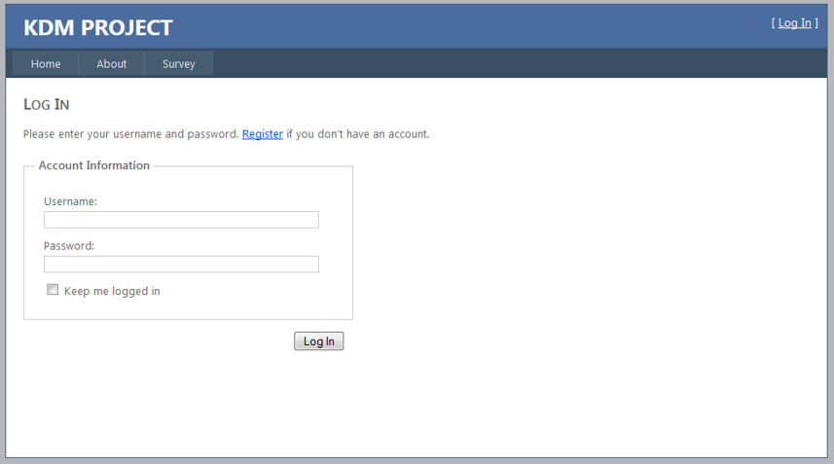

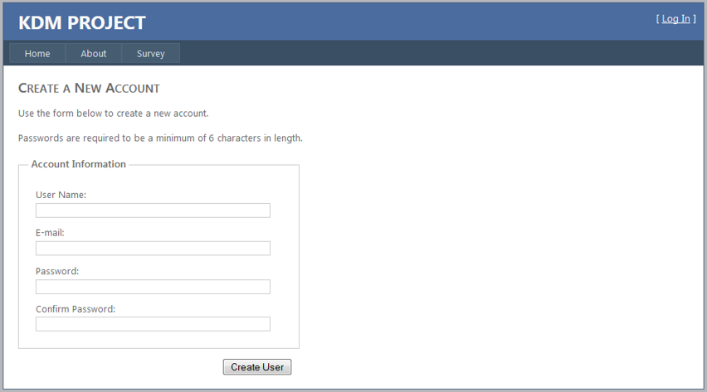

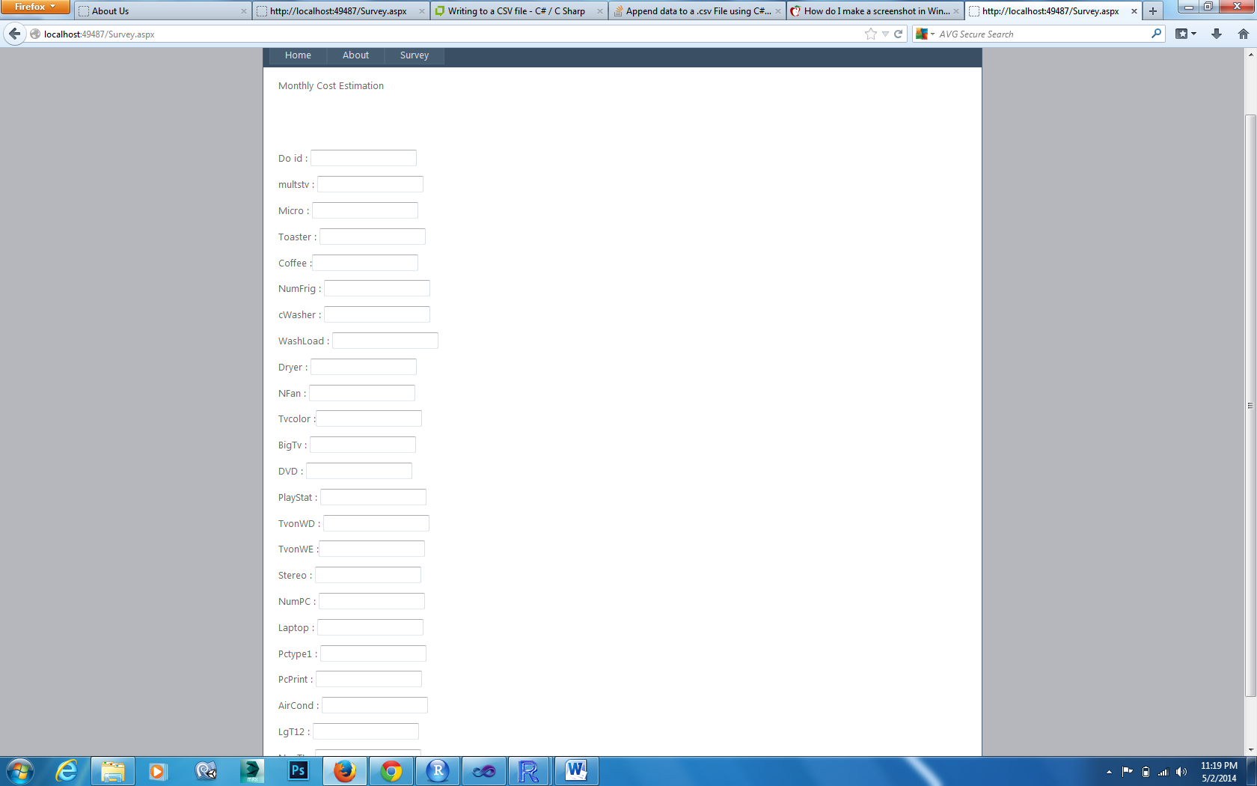



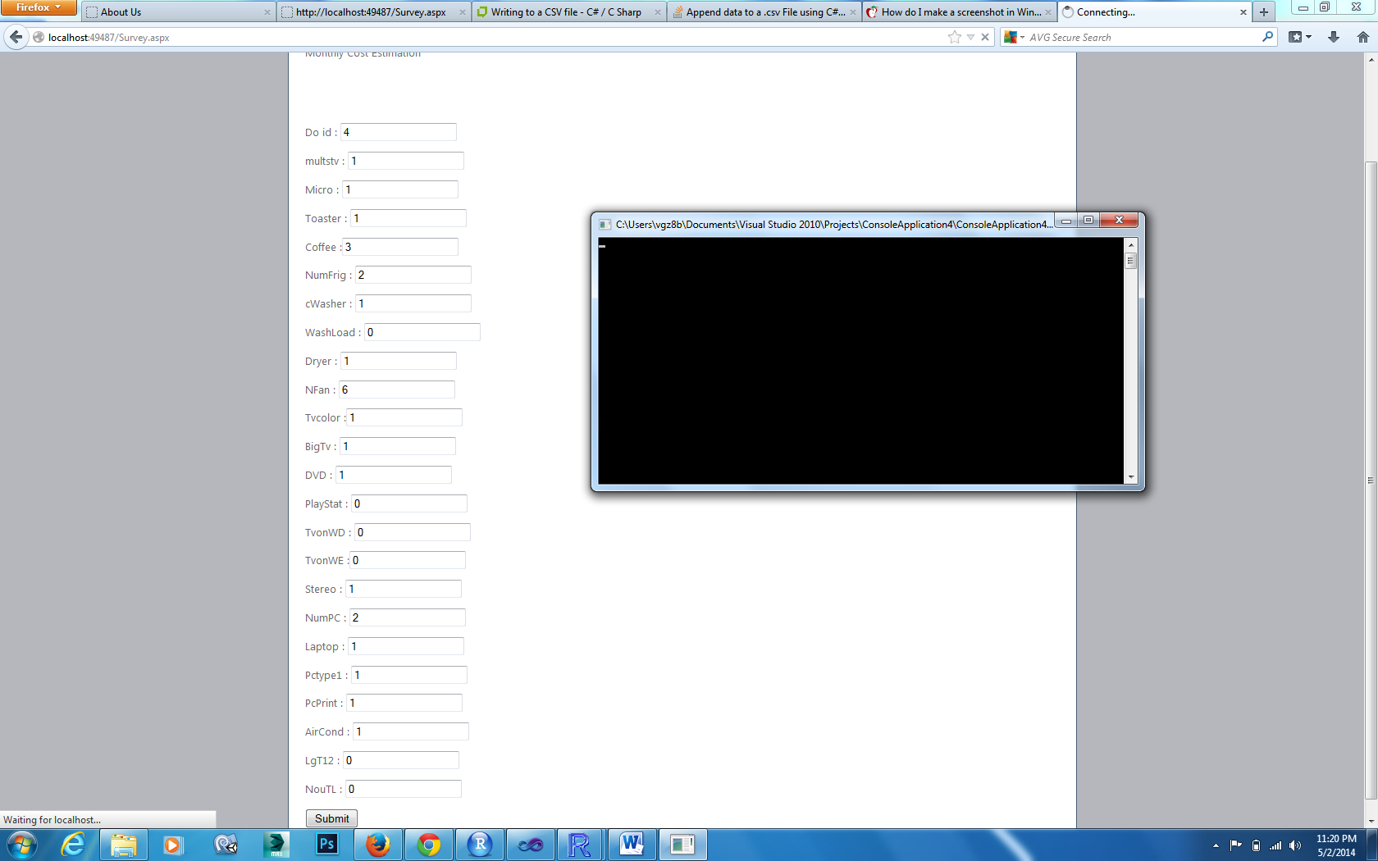

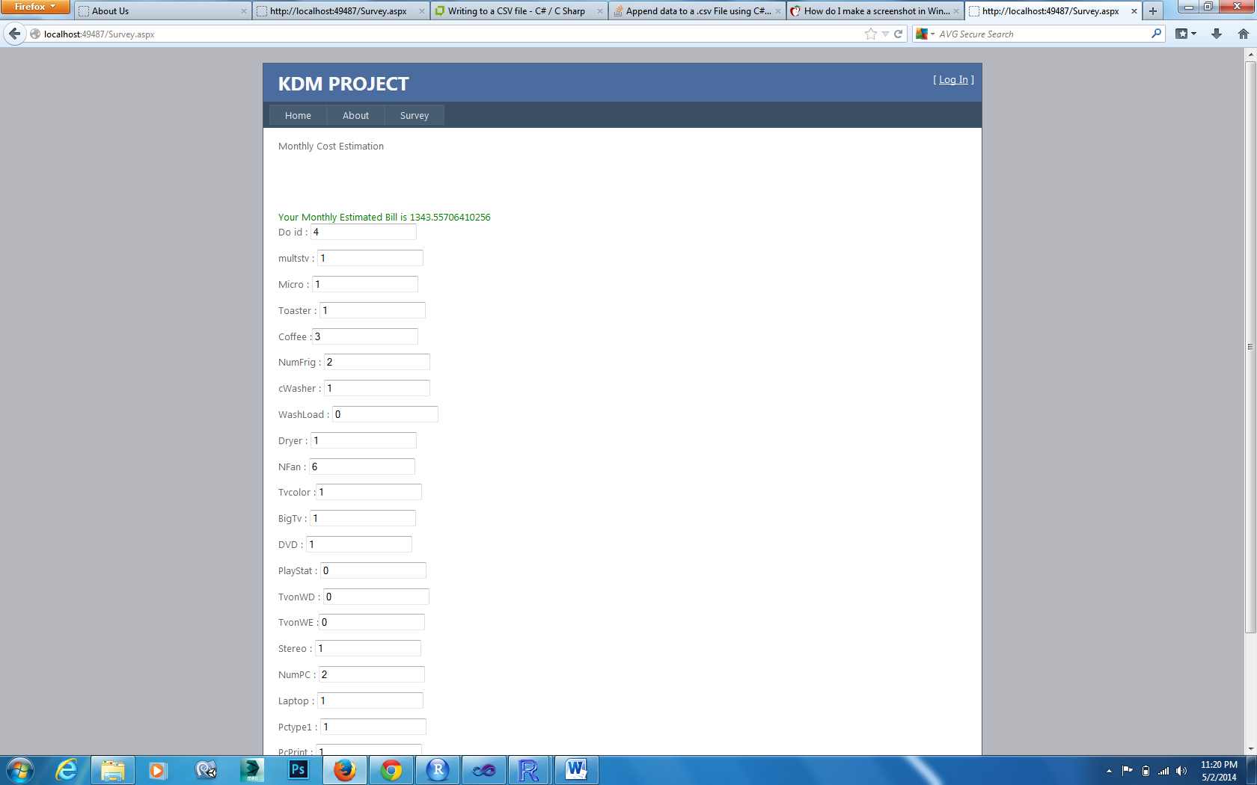

1. **Future Enhancements:**

* Once the user understands the average electricity charges per month in his community, he/she can set an over-limit value.
* Based on the daily usage, we would take the existing data (for every monthly cycle) and estimate the electric charges for the month.
* If the estimate charges crosses the over-limit value that was earlier set, he/she would be warned.
* Once the user enters the input and is recommended with the average electricity bill, this data has to sit in the database and first looked into in the future, if another user enters same input.

1. **You tube link:**

https://www.youtube.com/watch?v=HYL_pU4wlxM